**PROJECT GROUP 3:RAILWAYS SYSTEMS**

**1.PRADHYUMAN SHRINGI 19UCC073**

**2.RHYTHM BAJAJ 19UCC105**

**3.SAILESH KUMAR 19UCC072**

**4.SAI SHRUTI 19UCC088**

**DATABASE SCHEMA**

1.USER

create table user(

email_id varchar(30),

primary key(email_id),

pass_word varchar(30) not null,

name varchar(30),

gender char(6) not null,

age int not null,

aadharno bigint not null,

mobile_no bigint not null,

address varchar(40)

); 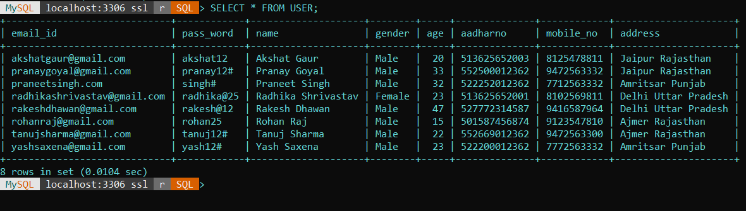

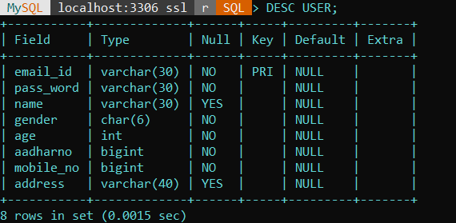

2.TICKET

create table ticket(

pnr_no int,

primary key(pnr_no),

name varchar(30),

train_no int,

train_name varchar(30),

age int,

email_id varchar(30),

foreign key(email_id) references user(email_id),

from_city varchar(30) not null,

to_city varchar(30) not null,

gender varchar(6),

seat_no int

);

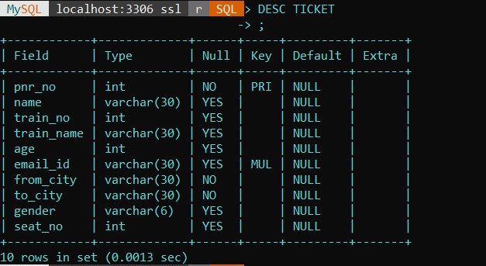

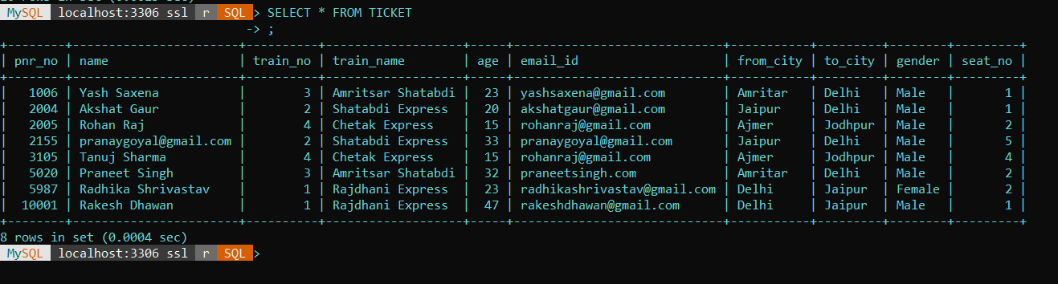

3.TRAIN

create table train (

train_no int,

arrival_time datetime not null,

destination_time datetime not null,

primary key(train_no),

train_name varchar(30),

source varchar(30),

destination varchar(30),

availableseats int ,

bookedseats int,

fare int

);

insert into train

values(1, '2020-12-12 3:00:00','2020-12-12 08:00:00','Rajdhani Express','Delhi','Jaipur', 28,2,400);

insert into train

values(2, '2020-12-15 15:00:00','2020-12-15 20:00:00','Shatabdi Express','Jaipur','Delhi',28,2,410);

insert into train

values(4, '2020-12-11 17:00:00','2020-12-11 22:00:00','Chetak Express','Ajmer','Jodhpur', 28,2,500);

insert into train

values(3, '2020-12-10 1:00:00','2020-12-10 08:00:00','Amritsar Shatabdi','Amritsar','Delhi', 28,2,800);

